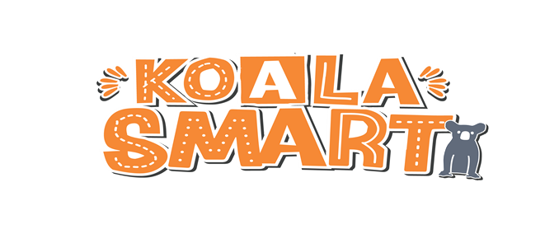

OVERVIEW OF THE KOALA SMART PROGRAM 2020

Koalas are facing greater threats than ever. The Tacking Point Lions Club’s partnership with the NSW government and environmental professionals initiated in 2019, continues to strengthen as the plight of koalas and other endangered animals continues to worsen.

Unprecedented bushfires in late 2019 and 2020 have had a devastating impact on koala populations as well as koala habitat in many parts of New South Wales. It is more important than ever to protect the habitat that remains and protect the animals still trying to survive. KOALA SMART is a program with the goal of educating, inspiring and driving change in local communities by generating ideas in the classroom and applying those ideas in the real world.

The Program
KOALA SMART is offered to all schools in New South Wales, particularly those where environmental stresses are evident.
School Involvement
When a school agrees to participate in the KOALA SMART program, students will be invited to address the question “What will you do to save the koala?”. Response should focus on the issues that threaten koala populations and outline what could be done if they had the necessary resources.
Each school will decide the format of their submission. Choices include (but are not limited to): Creative (dramatic, audio-visual, mixed media); Environmental science; Computer science; Practical (physical solutions for home or community use); Social (influencing the community to make behaviour changes); or Advocacy (such as working to convince Council to make a decision that favours koalas). The entry will need to be presented and documented in a digital format.

Through involvement in this program, teachers and students will engage in topical and meaningful activities that:
- Map to NESA syllabus outcomes:
- research and analysis of available information and data relating to the local koala population and its future
- problem solving and creative thinking in the arena of living things and the environment
- Contribute solutions to a potential environmental catastrophe
- Link with community organisations and other schools to work towards a common goal.

Timeline
Term 1 – school commitment – signed Agreement due 9 April 2020
Term 2 – commence addressing the question, and provide an outline of response by 3 July 2020
Term 3 – finalised submission due 27 August 2020
Term 4 – assessment and public display by 24 October 2020

Submission Guidelines
ADDRESS THE QUESTION: What will you do to save the Koala?

- An OUTLINE of your submission is due Friday 3 July 2020
Email to your local Lions Club and koala.country@environment.nsw.gov.au

- Your FINAL and COMPLETE submission is due Thursday 27 August 2020.

DIGITAL FORMAT: Submissions in digital format are to be emailed to XXX@XXX
Formats Accepted: Word, Powerpoint, pdf, avi, mp4, m4v, mkv, mov, mpeg4, mpeg, mpg, wmv (check with Lions Club representative well before submission date if intending to submit in a different format to listed here)
File size limit: 200Mb

Note: If the entry is a video production, the time should not exceed 4 minutes.

Entries may also include ‘hard copies’ – for example, posters, hand-outs for community distribution, paintings, models. If this applies, take a photo of the items and email as above. The original (or hard copies) will be included in the public displays. Original pieces may be requested by a Lions Club or KOALA SMART representative once assessment commences.

We suggest you keep a simple diary of the process taken by your students. Include resources used and contacts / relationships established. While it does not form a critical part of the judging process, it may aid in further development of the idea.

Project Support
Lions and the KOALA SMART program aim to minimise the impact on teachers’ workload by providing appropriate resources, for example:

- The KOALA SMART website simplifies access to relevant and accurate information by linking to appropriate government and non-government websites.
- Teaching modules and tools – including powerpoint presentations and videos
- Suggested ‘Critical Friends’: people (professional or volunteer) in your community who can provide guidance and advice, and ultimately assist with application.

{Insert local Lions contact details}

