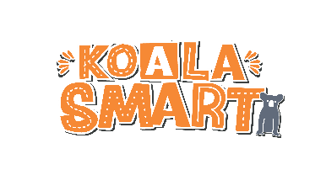
KOALA SMART
Project Participation Agreement
PROJECT DESCRIPTION: What will you do to save the koala?
KOALA SMART has evolved as a SCHOOL participation project with the goal of educating, inspiring and driving change in the local community. Content available to teachers and students via www.koalasmart.org.au has been crafted to align with the curriculum and offer multiple avenues to explore in the course of addressing the driving question: What will you do to save the koala?
The ultimate purpose of the project is to deliver a practical concept which can be applied in the real world.
Lions Participation
The wide-ranging ability of Lions Clubs to link relevant groups together to achieve a common goal is the foundation of this project. The KOALA SMART model has been created to encourage schools to link with their local Lions Club to become part of a larger state-wide network of people (both professional and volunteers) all working towards the same outcome: to slow the decline in koala populations and protect koala habitat.
Commitment: Lions Clubs are asked to commit to the project before the end March, 2020 by returning this Agreement.
1. As a partnering Lions Club you will adhere to the values of Koala Smart and adopt the project as it is intended. Tacking Point Lions Club (TPLC), as Managers of KOALA SMART will provide guidelines.
2. Prior to the end of Term 1, your KOALA SMART project team will seek commitment to the project from schools in the target area. TPLC KOALA SMART project team will provide information packs and password access to the KOALA SMART website. Every effort will be made to support your club with this project.
3. Before end of Term 3, your KOALA SMART project team will arrange critique of school entries and public display. Website resources, Saving Our Species staff and TPLC will assist if needed.
AGREEMENT
I . . . . . . . . . . . . . . . . . . . . . . . . . . . . . . . . . . . . . . . . . . . . . . . . . , . . . . . . . . . . . . . . . . . . . . . . . . . . . . . . . . . ,
[LIONS CLUB representative name] [position]

agree that . . . . . . . . . . . . . . . . . . . . . . . . . . . . . . . . . . . . . . . . . . . . . . . . . . . . . . . . . . . . . . . . . . . . . . . . . . . . .
[NAME OF CLUB]
will participate as outlined above in the Lions Club KOALA SMART project in 2020.
. . . . . . . . . . . . . . . . . . . . . . . . . . . . . . . . . . . . . . . . . . . . . . . . . . . . . .…… . . . . / . . . .. . /. . . . .
[signature] [date]

. . . . . . . . . . . . . . . . . . . . . . . . . . . . . . . . . . . . . . . . . . . . . . . . . . . . . .…… . . . . / . . . .. . /. . . . .
[TPLC KOALA SMART CHAIR] [date]

